EMAIL COMMUNICATION TEMPLATE

Hi All,

Welcome to REFFIND – a new employee engagement platform that will open a direct channel of communication to you through a smartphone app.

REFFIND is a fun and rewarding way for you to receive employee pulse surveys, job referrals, short-form video training and communications and an emergency roll call - straight to your mobile device.

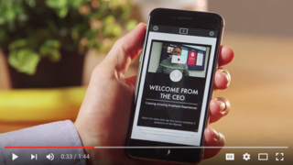

What are the benefits?

- Real-time feedback - we want to know what you think, so hearing from you regularly is important to us
- Stay in the loop - receive video comms from us whenever, wherever you are to stay in the know
- Learn more, faster - bite-sized training videos and quizzes sent to your mobile to facilitate fun, fast and engaging learning
- Refer your friends - help us find great talent who will fit our culture by referring our jobs to people you know
- Get Rewarded - successful referrals carry a $XK reward! Plus it’s gamified - the more jobs you action, the more chances you have to get rewarded!

Get on board and download REFFIND here. See you on the app!

Want to know more? See REFFIND in action.

